
TOWN MEETING 2026
QUESTIONS and ANSWERS
Proposed Fiscal Year 2027 Budget
Town of Essex
February 2, 2026

- How much is the proposed budget for fiscal year (FY) 2027 and how does it compare to the current fiscal year’s budget?
The proposed FY27 general fund budget is $17,189,166, an increase of $823,203 or 5.03% from FY26. The amount of the increase to be raised by property taxes (“tax levy”) is less than half of that amount at $391,779, or an increase of 3.31% from FY26.

These figures are exclusive of a separate ballot item for the Essex Human Services Contributions Fund, which could add $171,892 or 1% overall to the budget. If the Human Services funding is approved, the general fund budget would be $17,361,058, an increase of 2.56% in the tax rate.

The proposed budget will be published in the Town Annual Report, which is expected to arrive in mailboxes by February 21.

More details about Human Services Funding are available in an FAQ dedicated to that topic and on the Town of Essex website, www.essexvt.gov/budget.

- If this budget is approved by voters at Town Meeting, what impact will it have on the municipal tax rate and the amount an average property owner pays?
The proposed FY27 budget, not including Human Services funding, would increase the municipal tax rate by an estimated 2.54 percent, or $51.80 on the average home in Essex, which is assessed at $280,000. The resulting municipal tax rate would be $0.7481 (per $100 of assessed value). On a home assessed at $280,000 that equates to a municipal tax bill of $2,095.

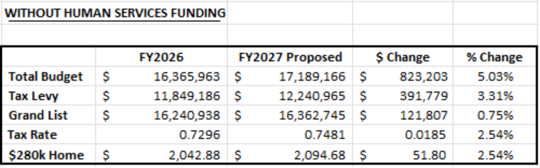

Assessed value can be found by looking at your current tax bill. Assessed value is not the same as market value.

If the Human Services funding is approved along with the proposed FY27 budget, the municipal tax rate would increase by an estimated 2.56%, or $52.92 on the average home in Essex. The resulting municipal tax rate would be $0.7586 (per $100 of assessed value). On a home assessed at $280,000, that equates to a municipal tax bill of $2,124.

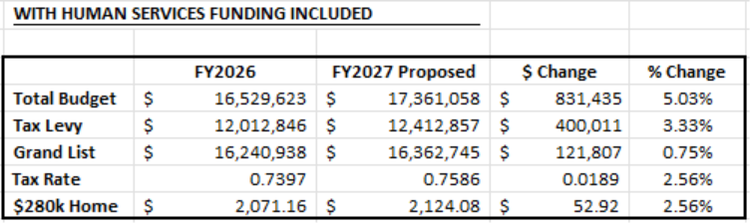

These projections are based on a 0.75 percent growth in the grand list. Should grand list growth exceed this projection, the tax rate set in the summer would be adjusted downward accordingly.

Please note that the projected tax rates shown above do not include the current 5-cent capital tax, or the local agreement rate for Farm and Open Lands Contracts and Veterans’ Exemptions, which historically is approximately 0.002 cents.

- What are the main cost drivers in the FY27 budget?
Personnel costs, including benefits, have a significant impact on overall budget costs as most of the operating budget supports direct service provision by our staff. Increases in these areas total $897,874. The contracting out of summer maintenance at 5 Town facilities, and plowing of cul-de-sacs, add expenses to the General Fund. Inflation has also driven up many costs, including contractual raises to staff, construction supplies, parts and equipment, vendor services, utility costs, and more.

- What is happening in the FY27 budget to limit expenses?
Staff identified $277,522 in cost savings to reduce needed increases in the property tax rate. These efforts include successfully negotiating with the City of Essex Junction to increase their contribution to Shared Assessing services from 43% to 50%; Fuel costs have decreased $54,406 from FY26; Professional services were reduced by approximately $50,000; and vacancy rates were increased in Police – Patrol and added for Public Works – Highway to better reflect historical spending.

Capital transfers out of the operating budget were eliminated in FY27 following a successful Town Meeting vote in March of 2025 to increase the capital tax rate to 5 cents. The use of $78,498 in fund balance to offset one-time expenses, and historically low health insurance premium increases also contribute to cost savings in FY27.

- What staffing, salary, or departmental changes are proposed in the FY27 budget?
- A new contract with the Essex Police Employees Association took effect in FY26.
- The Assessing Department will continue shared services with the City of Essex Junction, with staffing to increase from 1.7 full-time equivalents (FTEs) to 2.0 FTEs. The shared services agreement had been set to expire at the end of Reappraisal. Increasing to 2 FTEs was an important step in providing consistent service, will support succession planning, and, crucially, was cheaper than downsizing to 1.0 FTE and losing the contributing payment from Essex Junction.
- Market adjustments for Public Works staff covered by the American Federation of State, County and Municipal Employees (AFSCME) union were made in FY26.
- The Parks and Recreation Department reorganized within the confines of the approved budget.
- The retirement of a Support Services Director (0.6 FTE) in the Police Administration budget allows for the hire of a second lieutenant.
- A half-time Economic Development Coordinator position (20 hrs/wk) supporting these efforts has been absorbed by the Manager’s Office. This shift also allows for the existing part-time Manager’s Administrative Assistant to become full-time and provide additional support for human resources and administrative services without increasing FTEs.
- An increase of 9.5 substitute librarian hours per week in Essex Free Library is proposed to provide better staff coverage and enhance service offerings, especially to those who live in the community but cannot travel to the Library to access materials.
- Another important change is the anticipated shift of restorative justice services from the Essex Community Justice Center to a Chittenden County Community Justice Center, which will live with the City of Burlington. The change is not projected to have any impact on the budget because the State of Vermont provides grant funding for the bulk of CJC costs. The Town has historically contributed an additional amount to cover the costs of rent, salary and benefit increases, and restorative justice services not covered by the State grant. The FY27 budget for restorative justice remains level funded from FY26 at $46,200. That amount will support a successful transition and possibly allow restorative justice services in Essex to continue beyond what is paid for by the State. The shift to Burlington will, however, reduce the number of FTEs employed by the Town of Essex by an anticipated 2.6 FTEs.

- What Capital Budget items are being proposed in FY27?
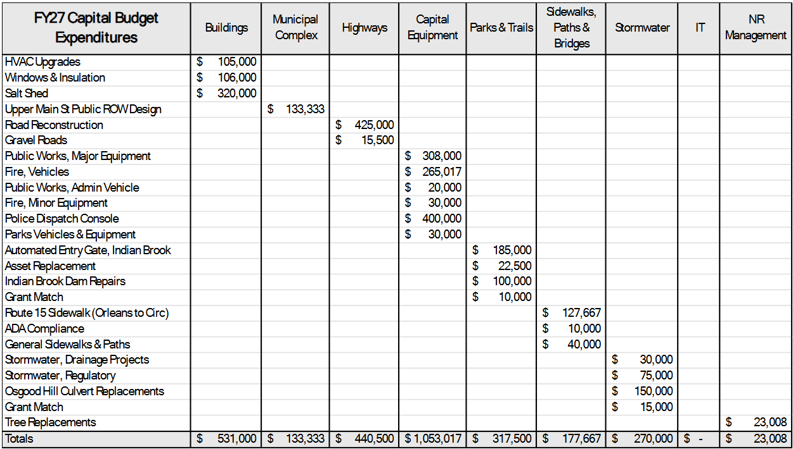
The proposed FY27 capital plan calls for capital tax additions of $1,492,232, spending of $2,946,025, and an ending balance of $3,530,732. Capital projects proposed for FY27 are listed below:

More details about specific projects are available online at www.essexvt.gov/budget.

- How much is fund balance and is there any available for reducing taxes?
The Town’s policy is to maintain an unassigned fund balance of up to 15 percent of the operating budget, which equates to approximately eight weeks of operating expenses. The Government Finance Officers Association recommends keeping at least two months of operating expenses in unassigned fund balance so that municipalities can operate during a natural disaster, an emergency, or some other type of unexpected event.

The Selectboard has approved the use of an additional $78,498 in fund balance to cover one-time expenses in the FY27 budget: a salary and benefits study required by the AFSCME union contract ($40,000), stipends for the Board of Civil Authority for meetings related to the reappraisal ($2,000), police equipment ($23,648), accessibility improvements at Essex Free Library ($7,500), installation costs for a new phone system ($4,050), and a RecTrac / Vermont Systems app ($1,300).

The FY27 budget does not use any fund balance to reduce the tax rate, which achieves a goal the Selectboard has been working to accomplish over the past few years. While in the short term the practice of using fund balance for tax reduction accomplishes a lower tax rate in the immediately following FY budget, it creates a gap in funding for the subsequent year that can often require a higher-than-average increase in the tax rate to avoid having to reduce service levels.

- How will completing the town-wide reappraisal affect the tax rate?
The objective of a town-wide Reappraisal is to re-value all properties at the same time based on current market and sales data. This ensures that properties with similar land uses, densities, and sizes are valued similarly. Because municipal taxes are primarily based on property value, this process is crucial to ensuring all taxpayers are paying taxes that correctly correlate to their property’s relative value in the community. The Town budget will not be changed by Reappraisal; the Town will still only need to raise the amount of the approved budget. If the assessed value of property in Town increases, the tax rate will decrease accordingly to only raise the amount of the approved budget when the Selectboard sets the tax rate around July 2026.

Please note, the amount raised by the 5-cent capital tax will change proportionally with each property’s assessment. For instance, if a home doubles in value, the amount of the capital tax will also double.

- When and where do residents vote on the budget?
Voting on the budget will occur by Australian ballot at the polls, which will be open on Tuesday, March 3 from 7 a.m. to 7 p.m. at Essex Middle School, 60 Founders Road, Essex.

Voters can also request an early ballot (see below for more info on how to do so).

Voters are encouraged to attend the Selectboard’s February 23 meeting (via Zoom or at the Town Offices, 81 Main St., Essex Junction) and the Informational Town Meeting at 7:00 p.m. on Monday, March 2 at the Essex Middle School, 60 Founders Road, Essex. Both meetings will include a presentation about the proposed FY27 budget.

- Are there any special articles that voters are being asked to consider at Town Meeting besides the budget?
Yes. In addition to the budget, the Town Meeting ballot will have questions about the following:

- Whether to appropriate an amount equal to 1% of the General Fund budget to the Essex Human Services Contribution Fund (see Human Services Contributions FAQ for more information)
- Two questions related to the proposed municipal complex at 80 and 90 Upper Main Street
- Whether to approve setting the number of Essex Development Review Board members to five (5), in accordance with 24 VSA 4460(f) (see FAQ)
- Election of the following:
  - Moderator, 1 vacancy (1-year term)
  - Selectboard, 3 vacancies (two 3-year terms, one 1-year term))

More details about these items are available in other Question and Answer info sheets, which can be found online at www.essexvt.gov/townmeeting.

- Will I receive my ballot early and how do I return it?
Voters will only receive a ballot early if one is requested.

Voters may visit the Town Offices at 81 Main St., Essex Junction to vote in the office, pick up a ballot to take home, or to request that a ballot be mailed.

Ballots can also be requested to be mailed by emailing clerk@essex.org; calling 802-879-0413, option 6; or requesting online at www.mvp.vermont.gov.

To be counted, ballots must be returned before the polls close on Town Meeting Day on March 3 (7 p.m.). Voters returning ballots on Town Meeting Day must deliver the ballot directly to the polling place (Essex Middle School).

A secure ballot box will be available at the Town Offices for those who may wish to return voted ballots after hours or on weekends up until the morning of March 3.

